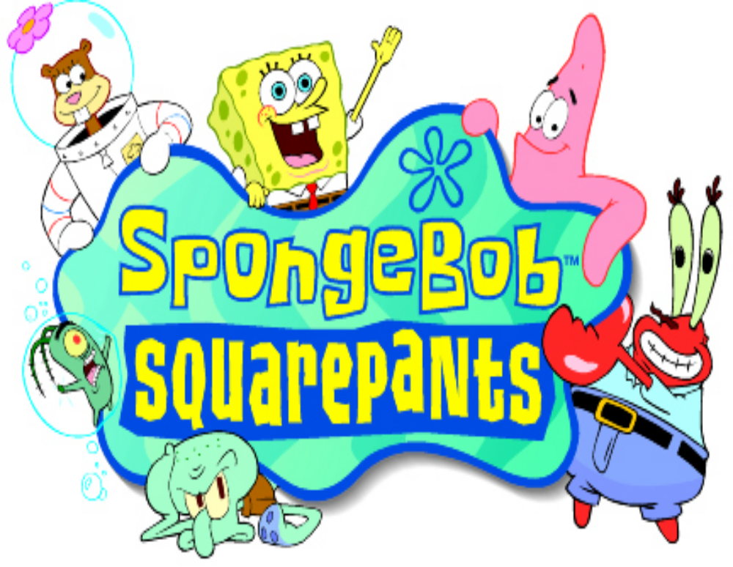User Interface

Contents

Document History 3
Front End 4
Front End Flow 4
Menus 5
Main Menu 5
Start Game Menu 5
Choosing a Memory Slot (PlayStation Only) 6
Entering a Password (GAME BOY Only) 6
Options Menu 7
Credits 7
Map Screen 8
Map Screen Navigation 8
Kelp World 8
Level Complete 9
Score Rating 9
Kelp World Ticket 10
Losing Lives & Game Over 10
Winning The Game 10
Cheats 11
Game Controls 12
Game Controls 12
Overview 12
Movement 12
Actions 12
Using Items 13
Menus & Speech Bubbles 13
PlayStation 14
GAME BOY Advance 14
Control Summary 15
Game Information 16
Health Meter 16
Ammo Counter 16
Pause Menu 17
Pickups 18
Speech bubbles 18

Document History

Version | Date | Author | Notes
0.1 | 20/11/00 | MD | Document Created
0.2 | 30/11/00 | MD | Password & Map Screen Revisions

Authors:

MD | Mark Davies (Climax)

Front End

Front End Flow

The game follows the standard game procedures starting with copyright notices and company logos before prompting the user for their language choice – the default being English.

The title FMA is then played – unless interrupted by the player pressing start it will eventually reach the Start Screen. Unless the player presses start before 10 seconds has surpassed a rolling demo will begin to play. Otherwise the main menu will be displayed.

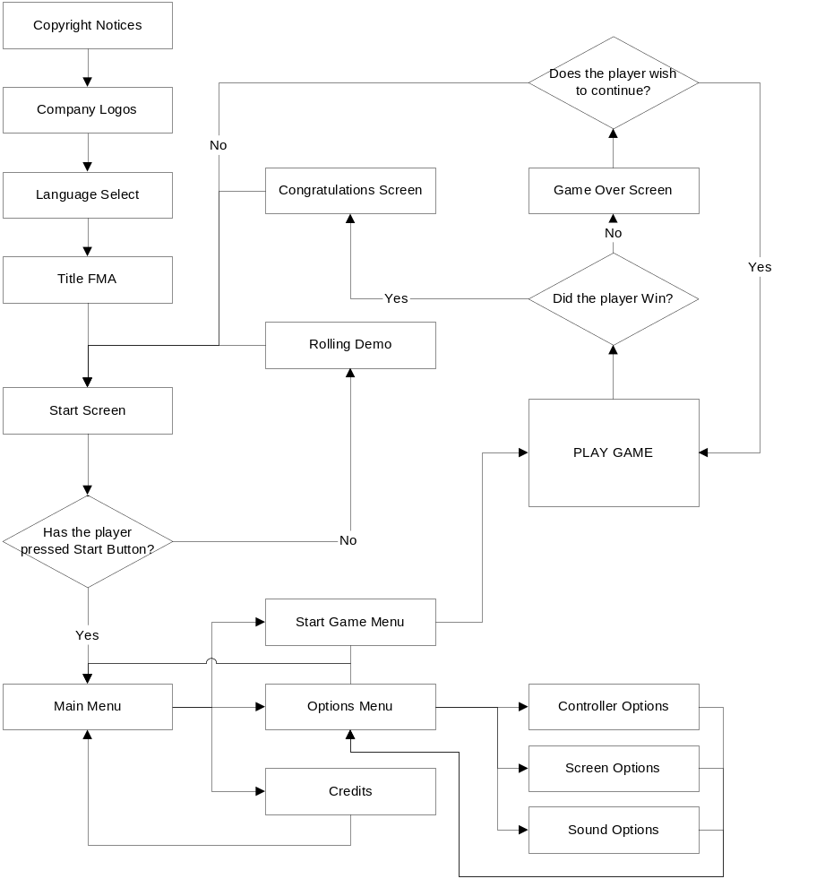

Menus

Once the player has pressed the Start button on the Start Screen, the main menu will be displayed. The menus operate with a simple up and down cursor and highlighted sentence. The D-Pad controls this up and down movement, and the use of start or the action button will select a menu item. The jump button can be used as a cancel button to go back one level if the player chose the wrong menu item.

Main Menu

The Main Menu has three choices for the player: Start Game, Options and Credits.

Start Game will move the player onto the Start Game Menu.

Options will move the player to the Options menu.

Credits will allow the player to view the production credits for the game.

Start Game Menu

Due to differences in the two target platforms, the start game menu differs slightly between the two game formats.

Playstation:
The PlayStation version makes use of the memory card, and takes up only one memory slot. Up to three separate games can be saved in this slot, allowing up to three players to save their progress.

GAME BOY Advance:
The GAME BOY version requires the player to enter passwords, as there is no memory feature available with cartridge. A screen is presented to the player, asking them to either ‘Start New Game’ or ‘Enter Password’. Starting a new game will take the player to the map screen with only the first level available to them. Entering a password requires them to enter a string of special characters. The player is then transported to the map screen where the level unlocked by the passwords and any preceding levels will be unlocked.

Choosing a Memory Slot (PlayStation Only)

The player is greeted with a simple screen that has 3 large picture squares. The picture in the square indicates the players’ furthest point in the game. A cursor surrounds the currently selected game, and can be moved left and right with the D-Pad. Pressing the action button will load the game and take the player to the Map Screen. If this is the player’s first game then the picture will indicate that it is a blank slot, all level information will be saved to this new slot. If there are no spare memory slots the player will be notified that they will not be able to save the game.

Entering a Password (GAME BOY Only)

The password system is a 6-character string made up from eight different icons. These icons are distinctive pictures in different colors that make memorizing the passwords easy. The eight icons are: a glove balloon, a kelp bar, a bubble wand, a net, a jellyfish, a patty burger, a golden spatula and a pair of glasses.

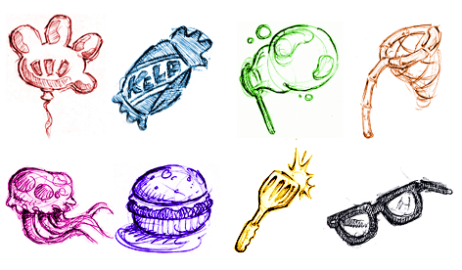

A password is entered on a special screen where there are six blank spaces. Beneath this is a small ‘keypad’ with the four icons and a square cursor that surrounds the currently selected icon.

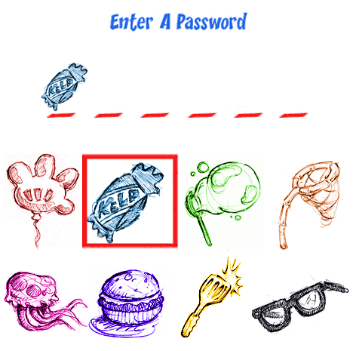

The D-Pad is used to move the cursor left, right, up and down the action button is used to select an icon and the jump button is used to cancel an icon. If a password is entered correctly the player will be taken directly to the map screen, otherwise an ‘Incorrect Password’ message will be displayed before taking them back to the Start Game menu.

Options Menu

There are a few options open to the player on both formats: Control Options, Screen Options and Sound Options.

Control Options:
Here the player can change the set up of the controller – i.e. which buttons the action and jump functions are assigned to. This is achieved via a set of predefined layouts, the player pushes left or right to choose the layout they want, and then presses start when they are happy. There will be only two layouts for the GAME BOY as there are only two buttons available (aside from the shoulder buttons) – the PlayStation has four layouts available.

Screen Options (PlayStation Only):
This menu allows the player to adjust the screen to suit their needs – this allows them to position the playfield to their liking. Two sliders control horizontal and vertical movement. The player selects the appropriate slider and then moves the D-Pad left or right from a center point.

Sound Options:
Here the player can set up the sound parameters of the game to their liking. Sliding bars indicate the level of the Music Volume, Speech Volume (PlayStation only) and the SFX Volume. These volumes are adjusted with ease by selecting the appropriate bar and moving the D-Pad left and right.

Credits

The credits display a list of all the people that were involved with the project, as well as giving thanks to those that lent their help and support. The credits are presented in a cartoon style, and (time permitting) feature a SpongeBob style caricature of the key members of the development team / publishers.

Map Screen

Once a game has been selected, either through the memory card, via a password or by starting a new game – the player will now arrive at the map screen.

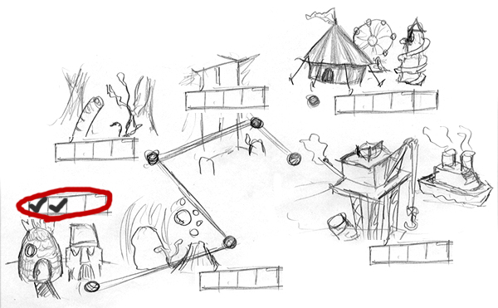

Map Screen Navigation

Each of the five locations are displayed on the map, as well as the bonus levels of Kelp World. A line links the five main chapters, and shows the route SB will have to travel. Next to each location is a set of four boxes – these indicate SB’s progress within a chapter. Each box represents a level, and a large tick in the appropriate box will show each level that the player has completed.

Once a level has been completed the player may return to it at any point. The player can move around the various locations on the map screen with the D-Pad – a red circle around the level boxes shows the location currently selected. Pressing the action button will ‘lock on’ to the location, this allows the player to select the level they want to play. Clicking the action button again will load this level and the game will begin, otherwise the player can press cancel and choose another location. Locations are only unlocked when all the levels of the previous location have been completed.

Kelp World

Kelp World is unlike all the other locations in that it requires the player to unlock special tickets before they can enter. Each bonus level requires a ticket garnered from each chapter. These tickets are obtained by reaching a target score within any one level of that chapter (see section on Level Complete). Kelp World can be chosen at any point once unlocked, but only the levels within can only be unlocked from the relevant chapter.

Level Complete

Once a level is complete the player will be given a breakdown of how well they performed in the level. This score is based on several factors:

Statistic | Description
Hit Accuracy | How many of the fired projectiles hit an enemy or target.
Number of Spatulas | The percentage of spatulas found on the level against how many were available in total.
Skill | How many times the player died on the level.

The total score is a percentage based on:

((Hit Accuracy + Percentage of Spatulas) / 2) * (2 / (Number of Deaths+1))

All decimal figures are rounded up – and any scores over 100% are reduced to 100.

Score Rating

Besides their percentages next to the Statistics, the player will also receive a comment as to how well they completed the level. This comment is based on their total percentage:

Total Percentage | Rating
0-20% | Lame!
21-40 | Poor
41-60 | Average
61-80 | Good
81-94 | Great
95+ | Amazing!

After this summary the player will be returned to the Map select screen, where a new tick will have appeared next to the level they have just completed. If they have now completed a chapter the next location will be available for selection.

Kelp World Ticket

For ‘Amazing!’ scores the player will be awarded a ticket to Kelp World. Each chapter will unlock only one Kelp World ticket, but an Amazing! Score from any level in that chapter will secure the player a ticket.

Losing Lives & Game Over

When the player loses a life they will be taken back to the last checkpoint they reached, or the start of the level if they have not yet reached a checkpoint. Once a player has used up all of their lives they will be taken to the Game Over screen and asked if they wish to continue. If they do they will restart the same level from the beginning with the default amount of lives. If they answer no then they will be taken back to the Start Screen.

Once back at the Start Screen the player is free to load a game from the last saved position or enter a password as normal.

Winning The Game

The game is won by completing all levels of the first 5 chapters. If this is achieved then the player will see the end FMA sequence, and will be given the cheat code for Rambo Mode. There are also a number of bonus games in Kelp World that will be unlocked by completing the chapters. Completion of each bonus game will divulge another cheat code. If all of these bonus games are also completed an extra FMA sequence will be shown.

Cheats

There are a number of cheat codes that the player can enter to unlock special features of the game. All of these are entered on the Start Screen. They involve a combination of buttons and D-Pad directions. Only one cheat can be used at a time.

Cheat Name | Description | Sequence
Rambo Mode | Permanent Jelly Launcher & Infinite Ammo | Action, Action, Action, Right, Action
Neil Armstrong Mode | Low Gravity makes jumps higher | Up, Up, Up, Action, Jump
Speedy Gonzales Mode | Makes SB run twice as fast | Right, Right, Right, Action, Jump
Super Hero Mode | Infinite Lives | Down, Down, Action, Jump
Wonky Mode | Direction buttons are reversed | Up, Down, Left, Right, Jump, Jump
Aussie Mode | Flips the screen upside down | Down, Down, Down, Down, Action, Jump

Game Controls

Overview

SpongeBob’s target audience is the 8-13 age group, and as such has controls that are as simple to use as possible. On both formats the controls follow an intuitive format in that one button is used to jump, one is used for every action and the D-Pad is used to control the character’s movement.

Movement
The D-Pad is used to perform the majority of SB’s moves.

- Left and right on the directional pad will move SB accordingly.

- Holding down on the D-pad will enable SB to duck, the camera will also pan down slightly to show the area below SB. When released the camera resets to it’s default position.

- Push up on the D-pad to look and pan above the player. When released the camera resets to it’s default position.

- Jump button. In conjunction with the D-pad SB can perform a directional jump. If the player presses and holds down the jump button he will perform a higher jump than if pressed & released quickly.

Actions
There are several actions that SB can perform:

- As well as ducking, pressing down on the D-Pad doubles up so that the player can soak up water in dry environments and still breathe.

- The up button is used to talk to NPC’s by pressing it within close proximity.

- Pressing the action button will use the current item in SB’s possession, however the use of each specific item is unique. When SB has no item in his possession the action button will perform a Karate Chop.

- Whilst in mid air SB can perform a Butt Bounce by pressing D-Pad Down.

Using Items

Each item is used in a slightly different way, however all are controlled via the action button (unless they are activated automatically on pick up).

Item | Usage
Ol’ Reliable | One press of the action button is required to capture a Jellyfish in the net. A second press of the action button will fire the Jellyfish in the direction of travel. The Jellyfish can also be fired straight up by pressing the up D-Pad with the action button.
Jellyfish Launcher | The Jellyfish Launcher has a limited amount of ammo, which SB must replenish by collecting Ammo Jars. Pressing the action button will fire a jellyfish in the direction of travel, though the direction can be changed by pressing a D-Pad button at the same time. The Launcher will fire in one of seven directions (all directions except down).
Coral Blower | Pressing and holding the action will suck button a nearby object into the blower. An aiming cursor will now appear on screen, the direction of which can be altered with the up and down D-Pad keys (within a 140° arc). Once the action button is released the object will be fired in the direction of the aiming cursor.
Bubble Wand | Pressing the action button will create a bubble directly in front of the player.
Diving Helmet | Automatically activates. Pressing the action button will perform a Karate Chop.
Glasses | Automatically activates – can be used in conjunction with other power-ups.
Squeaky Boots | Automatically activates – can be used in conjunction with other power-ups.
Super Hero Ring | Automatically activates – can be used in conjunction with other power-ups.
Disguise | Automatically activates. Pressing the action button will perform a Karate Chop.

Menus & Speech Bubbles

Before starting a game, or whilst a game is paused, the player will have to navigate a series of menus. These are simply lists of available options that can be scrolled through by pressing the up and down buttons on the D-Pad. A highlighted menu item is selected by one simple push of the action button.

During the game the player will be able to talk to NPC characters. This is achieved by the use of speech bubbles. The action button is used to forward to the next speech bubble, or pressing start will skip all of the current conversation.

PlayStation

The PlayStation controller also enables use of the left analogue stick, as well as the standard D-Pad for movement. The analogue control will allows for a slightly slower running speed when the stick is moved by a small amount otherwise it has a similar functionality to the D-Pad. Square is used to perform a jump, and X will perform any given action.

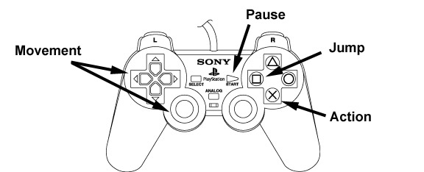

GAME BOY Advance

The GAME BOY uses the D-Pad for movement. The A button is used to make SpongeBob jump and the B button is used as the action button.

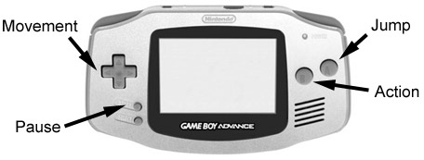

Control Summary

Function | Button
Move Left | D-Pad Left
Move Right | D-Pad Right
Duck | D-Pad Down
Soak Up Water | D-Pad Down over Puddle
Move Camera Down | D-Pad Down
Butt Bounce | D-Pad Down in Mid-Air
Move Cursor Down | D-Pad Down
Talk to NPC | D-Pad Up
Move Camera Up | D-Pad Up
Move Cursor Up | D-Pad Up
Fire Current Weapon | Action Button (+ Direction to Aim with Certain Weapons)
Use Special Item | Action Button
Karate Chop | Action Button
Jump Up | Jump Button
Jump Up High | Keep Jump Depressed
Jump Left | Jump + D-Pad Left
Jump Right | Jump + D-Pad Right
Pause Game / View Stats | Start

Game Information

Health Meter

The Health Meter overlay remains off-screen until SB is hit, when it will scroll into its position in the top middle of the screen. It will remain there for 5 seconds before sliding back up again – unless the player only has one chunk of health left, in which case it will remain on screen until death or a health pick-up is acquired.

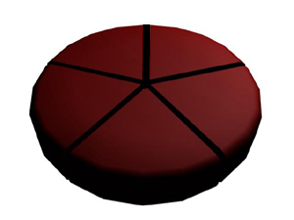
A 3-D rendered pie chart represents SB’s health, and is divided into five segments. Whenever an enemy hits SB, a chunk will be removed from this chart until SB has none left, at which point he will lose a life. When a health pick-up is collected the relevant number of chunks will reappear on the pie.

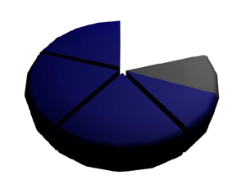
When the player is exposed to the air the Health Bar will scroll onto the screen coloured dark blue. As the player moves out of the water this blue bar will slowly tick away like a clock leaving a grey chunk behind. Every time a chunk is turned fully grey, that chunk of health will be removed. Each chunk of health provides 5 seconds without water. As SB uses his soak-up capability the current chunk will be replenished. As SB’s Health approaches 0 a warning sound will indicate to the player that they must find water very soon, the Health Meter will also flash on and off as an extra visual warning.

Ammo Counter

The Ammo Counter overlay is not permanently displayed on screen, but will slide into the bottom middle of the screen when needed.

Only two of the weapons require use of the ammo counter: the Jellyfish Launcher and the Bubble Wand. The ammo counter itself is dependant on the current weapon.

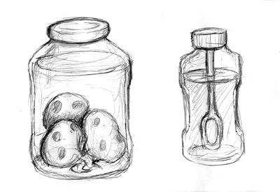
The Jellyfish Launcher counter is a Jam Jar filled with Jellyfish, and the Bubble Wand counter is a Bottle filled with Bubble Liquid. As the Jellyfish Launcher ammo is depleted a Jellyfish will be removed from the jar. Each time a bubble is used the liquid in the bottle will be reduced in volume. Once all ammo has been depleted the ammo counter will slide off screen.

Pause Menu

The game can be paused at any time, at which point the game world will dim in brightness and the game stats will be overlaid. At the top of the screen two icons represent the amount of lives a player has left and how many golden spatulas they have collected on the course of their travels.

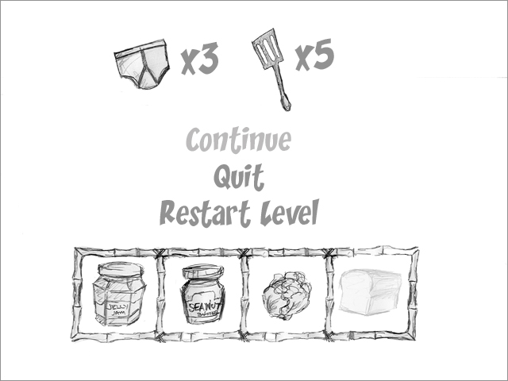

Underneath the icons is a menu that allows the player to: Continue, Quit or Restart Level. Although fairly self explanatory; Continue will resume the game from where the player paused it, Quit will exit the game and return to the main menu screen (after a confirmation to ensure they do not do this accidentally), and Restart Level will begin the current level again with the amount of lives they started the level with intact.

At the very bottom of the screen are the level objective boxes, which show the quest items SB has collected in the chapter so far. These will at first appear translucent until the item has been collected, when it will appear as a full colour icon.

Pickups

All pickups in the game float slightly above the ground, bobbing gently to distinguish them from their surroundings. Each pickup also has its own distinctive sound effect that is played briefly upon collection.

Pick Up | Sound Effect
Ol’ Reliable | Net Swoosh
Jellyfish Launcher | Splatting Jellyfish
Jellyfish Jam Jar Ammo | Gun Magazine Reload
Coral Blower | Vacuum Suck
Bubble Wand | Bubble Pop
Diving Helmet | Darth Vadar Breathing Sound
Squeaky Boots | Squeaky Sound
Balloon | Squeaky Rubber Noise (Popping Noise on Dropping)
Disguise | Groucho Marx Noise
Golden Spatula | Cash Register ‘Ca-Ching’
Salty Fries | Small Mmm
Salty Shakes | Medium Mmmmm
Patty Burger | Big Mmmmmmmmmmm
Glasses | (In a Smooth Voice) Cool!
Super Hero Ring | *Change in Music for Duration*
Extra Life | Wahoo!
Quest Item | Fanfare

Power-up pickups will show up on SB’s person, except for the Super Hero Ring, which will cause SB to flash on and off for the duration of its effect. Every time a Health pickup is acquired the Health Meter will slide on screen briefly to show the new energy level. The Extra Life pickup will briefly display ‘Extra Life’ on screen on collection.

Speech bubbles

When SB meets a NPC he may speak to them in order to acquire new items and information. All speech is handled by a Speech Bubble, which will appear at the bottom of the screen with the character’s face in the corner. The player simply presses the action button to cycle through the speech bubbles, or start to skip the conversation all together.

